Lab 14: Mobile_App_Investigations_Messaging
What You Need for this lab
  - Install Virtualbox : https://www.virtualbox.org/wiki/Downloads
  - Install Kali 2021.4. : https://old.kali.org/kali-images/kali-2021.4/
Notes: Suggest You configure the disk size of Kali VM 80G because the size of each leakage cases image is 30G+
  - Android Open-Source Project Apps :
  - https://digitalcorpora.s3.amazonaws.com/corpora/mobile/android_10/Non-Cellebrite%20Extraction/Pixel%203.zip

Step 1
- Download Pixel 3 image
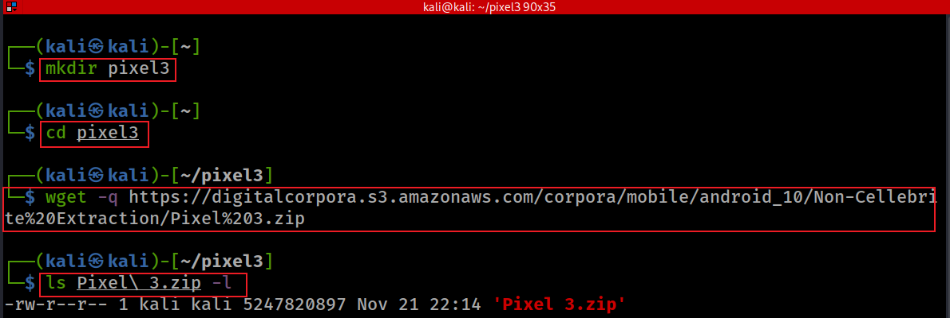
Verify hashes
hashdeep Pixel\ 3.zip
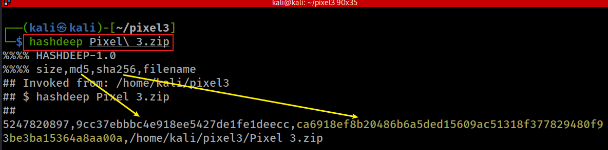
- unzip to get Pixel 3 image
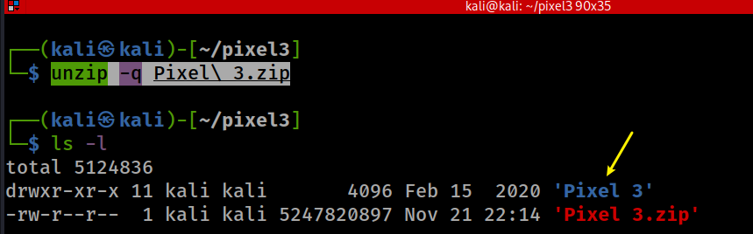
ls 'Pixel 3/data/data/'
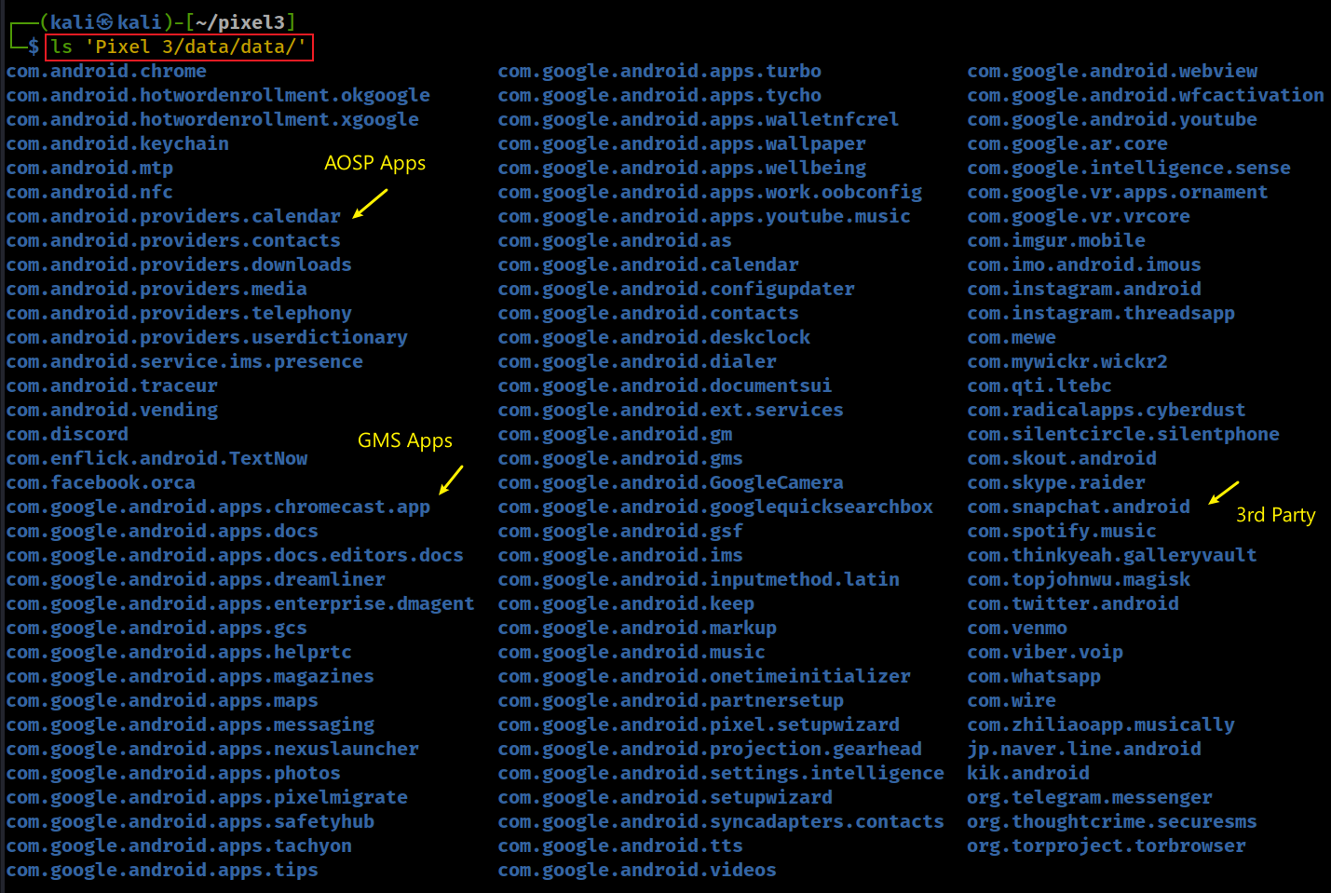
Step 2. Investigating Messaging Services
- Show all AOSP Apps/Packages: com.andriod.*
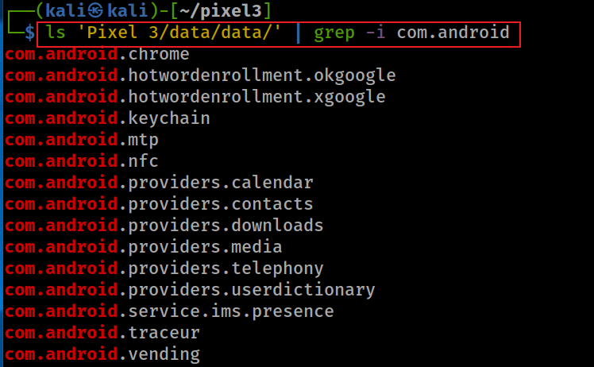
- Find the location of Java package
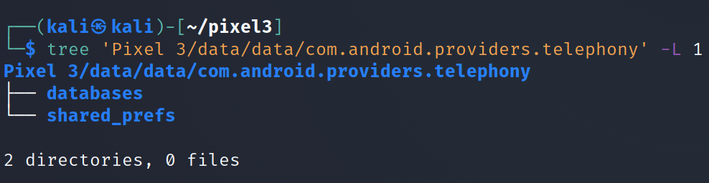
- Find the database location
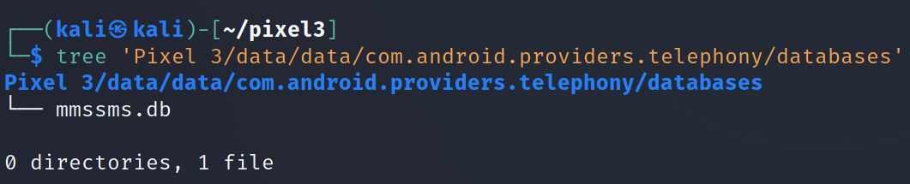
- Show all tables in the database
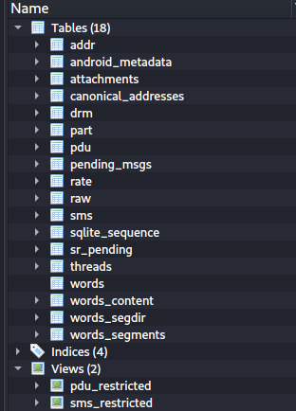
- sms: message log
  - Only system, phone or the default message app can have full access of sms data
- sms_restricted:
  - Only contains sent or received messages.
- threads
  - Group all messages based on incoming phone numbers and time period?
  - Exam sms table structure
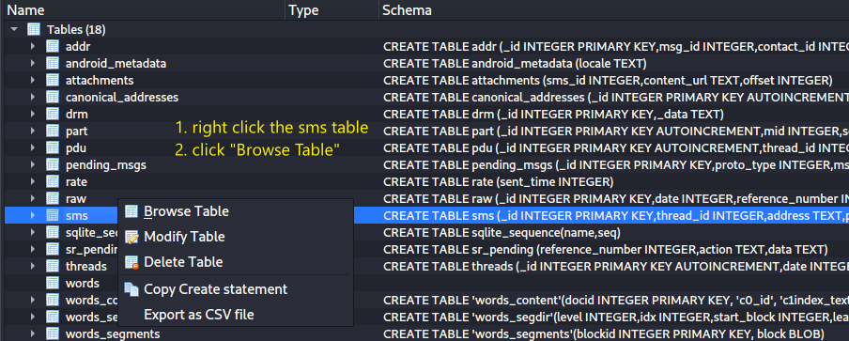
- Find clues to answer the question
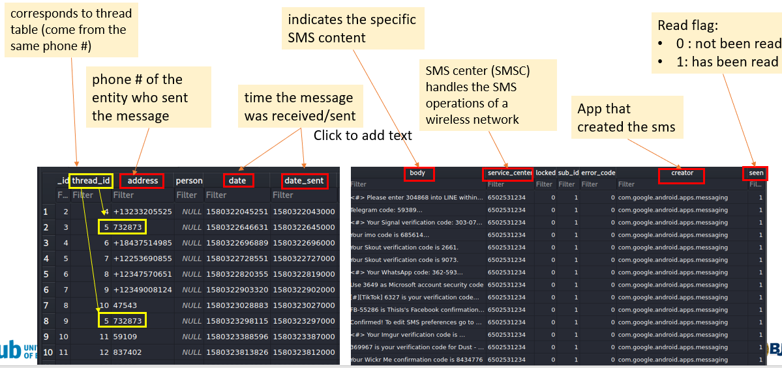
- Which message was received on Jan 29, 2020 around 6:20 pm?
https://www.epochconverter.com/
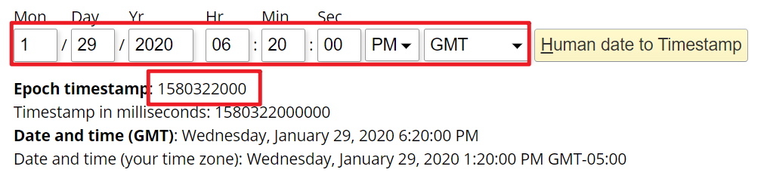
- Who sent the message?

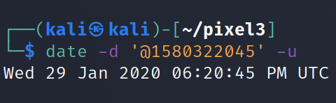
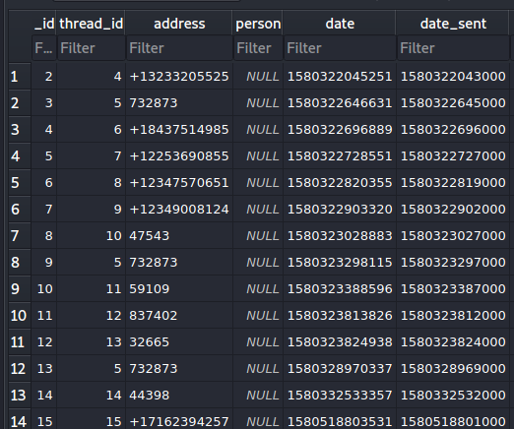
What table describes conversation?

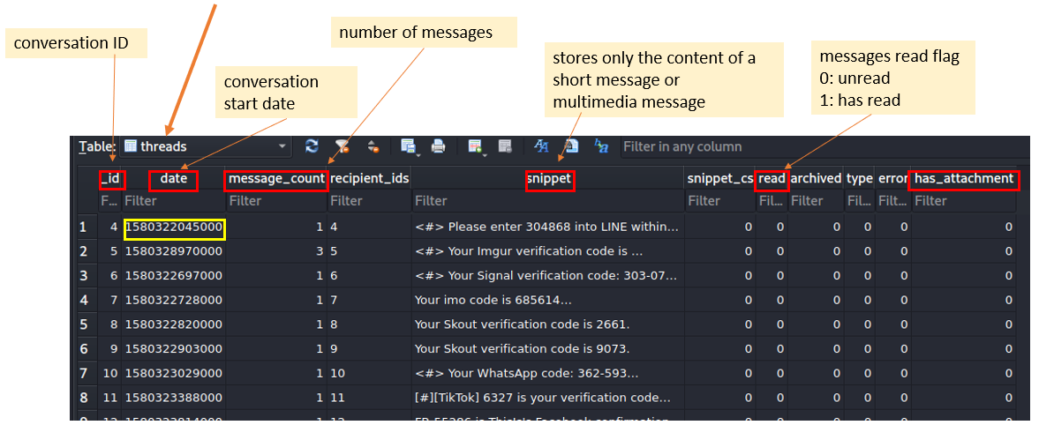
Where to find sender’s phone number?

Exam canonical_addresses table
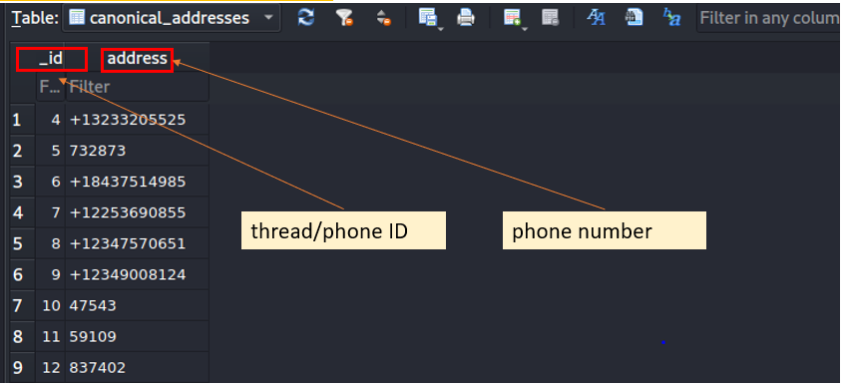
Which table contains MMS information ?

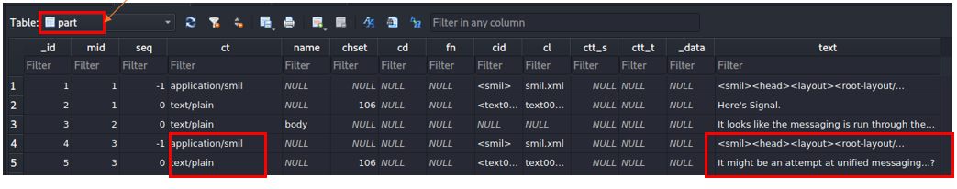
Part table stores below information:
- _id: Distinguish between different attachments of a multimedia message (including text, picture, audio, video and other formats)
- ct: indicates what type of attachment
- data: indicate where the attachment is stored on the phone
- text: Represents the body of the MMS.

YOU MUST SUBMIT A FULL-SCREEN IMAGE FOR FULL CREDIT!
Save the document with the filename "YOUR NAME Lab 14.pdf", replacing "YOUR NAME" with your real name.
Email the image to the instructor as an attachment to an e-mail message. Send it to: xxx@fe.edu.vn with a subject line of "Lab 14 From YOUR NAME", replacing "YOUR NAME" with your real name.

